Dear (Insert Recipient’s name),

On Sunday, September 16, 2018, I will be participating in the RBC Race for the Kids. I am hoping you will join me in supporting youth mental health programs at CHEO by participating with me and becoming part of (team name).

The RBC Race for the Kids is an all-terrain walk/run event in support of youth mental health programs at CHEO. All of the closed courses make their way through beautiful Wesley Clover Parks. Participants of all ages and abilities are welcome to participate in the event of their choice. Routes available are 5K and 10K timed races or the fully accessible 2K Family Fun Run. Each registered participant will receive a t-shirt, a finisher’s medal and enjoy a healthy breakfast, entertainment and activities for people of all ages, including the RBC Family Fun Zone.
Here is why I am asking you to join our team and help raise funds needed to support mental health care at CHEO.

In the last five years, CHEO has seen more and more children and young people struggling with their mental health. The demand for services including emergency, inpatient, outpatient and community care is increasing dramatically, stretching CHEO’s mental health system to the limit.
What was once thought of as an unusual surge in the need for children and youth mental health services has become the new normal. CHEO has seen a 75% increase in mental health emergency visits since 2010.

Our participation and fundraising will help CHEO’s youth mental health programs offer support to more kids, improve emergency care, re-establish dedicated mental health beds for young children and help parents and caregivers find the right services at the right time.

View our team page and become a member! (insert link to team fundraising page)

Together, we are going further for youth mental health!

Sincerely,

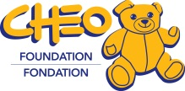
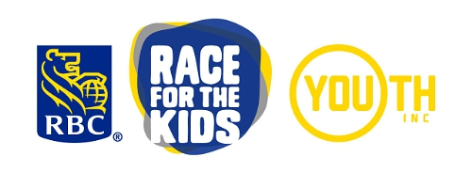
(NAME)

